**STOCK PRICE ALERT USING API**

***A mini project report submitted by***

**SAM LEO.S (URK20CS2005)**

***In partial fulfillment for the award of the degree***

***Of***

**BACHELOR OF TECHNOLOGY**

***In***

**COMPUTER SCIENCE AND ENGINEERING**

***Under the supervision of***

**MS.REYANA, Assistant Professor**



**DEPARTMENT OF COMPUTER SCIENCE AND ENGINEERING**

**KARUNYA INSTITUTE OF TECHNOLOGY AND SCIENCES**

(Declared as Deemed-to-be-under Sec-3 of the UGC Act, 1956)

**Karunya Nagar, Coimbatore - 641 114. INDIA**

**OCTOBER 2022**



**DEPARTMENT OF COMPUTER SCIENCE AND ENGINEERING**

**BONAFIDE CERTIFICATE**

This is to certify that the project report entitled, “Stock price alert using api” is a bonafide record of Mini Project work done during the odd semester of the academic year 2022-2023 by

**SAM LEO.S (Reg. No: URK20CS2005)**

in partial fulfillment of the requirements for the award of the degree of Bachelor of Technology in Computer Science and Engineering of Karunya Institute of Technology and Sciences.

Submitted for the Viva Voce held on _________________

**Signature of the Guide**

**ACKNOWLEDGEMENT**

First and foremost, I praise and thank ALMIGTHY GOD whose blessings have bestowed in me the will power and confidence to carry out my project.

I am grateful to our beloved founders Late**. Dr. D.G.S. Dhinakaran, C.A.I.I.B, Ph.D** and **Dr. Paul Dhinakaran, M.B.A, Ph.D**, for their love and always remembering us in their prayers.

I extend my thanks to our Vice Chancellor **Dr.P. Mannar Jawahar, Ph.D** and our Registrar **Dr. Elijah Blessing, M.E., Ph.D,** for giving me this opportunity to do the project.

I wish to extend my thanks to our Pro-Vice Chancellor (RC) **Dr. E.J. James** and **Dr. Ridling Margaret Waller** Pro-Vice Chancellor (QS), for providing me this opportunity to do the project.

I would like to thank **Dr. Prince Arulraj, M.E., Ph.D.,** Dean, School of Engineering and Technology for his direction and invaluable support to complete the same.

I would like to place my heart-felt thanks and gratitude to **Dr. J. Immanuel John Raja, M.E., Ph.D.,** Head of the Department, Computer Science and Engineering for his encouragement and guidance.

I feel it is a pleasure to be indebted to,Ms.reyana**,** AssistantProfessor, Department of Computer Science and Engineering and for his/her invaluable support, advice and encouragement.

I also thank all the staff members of the Department for extending their helping hands to make this project a successful one.

I would also like to thank all my friends and my parents who have prayed and helped me during the project work.

**Abstract**

Stock investors all agree that one of the hardest things they have to do is keep up with the rapid changes in the markets. The Internet carries a huge amount of up-to the minute information for investors such as current stock prices, exchange rates, sales volumes, latest deals, trading averages, organizations’ performance and financial information, oil and other goods prices, and much more. Although such stock-related information is publicly and freely available on the Internet, investors face difficulties tracking the changes and updates fast enough to make sound investment decisions.

It is extremely important to carry out a comprehensive research work before making an investment. It is only after in-depth research work, you can evaluate or predict the future performance of a share, specific sector or the stock market. Even if you are going through the stock market tips, then also it is imperative to perform a thorough research just to have a great peace of mind that the investment you are planning to undertake will yield profitable returns or not. When you are buying shares, then you are purchasing some portions of the business with an expectation to make profits if there is an increase in the business value.

Before buying a cloth or phone, you may be carrying out research to analyze their quality and performance. Similarly, when you are taking a stock market investment decision, then you must ensure that your hard-earned money is invested in the right place and does not go wasted. Types of stock analysis although stock analysis can take different forms, there are two main types that traders tend to favor. These are: Technical analysis, which takes a gander at the recorded value outlines of an advantage, and studies past market designs so as to anticipate future developments. Merchants will utilize key devices, similar to help and obstruction lines, to find out market patterns Fundamental analysis, which takes a gander at information from the organization and from its macroeconomic condition to evaluate potential benefits from exchanges.

It centers around information sources that are accessible to people in general, for example, an organization's monetary record and income streams The two assortments of stock analysis have the equivalent planned result: to settle on the right purchasing and selling choices and pick the ideal occasions to put exchanges. The development of this API is for analyzing and predicting stock market prices is a basic tool aimed at increasing the rate of investors’ interest in stock markets.

**CONTENTS**

Acknowledgement i

Abstract ii

**1. Introduction 6**

1.1 Introduction 6

1.2 Objectives 11

1.3 Motivation 12

1.4 Overview of the Project 13

1.5 Chapter wise Summary 13

**2. Analysis and Design 14**

2.1 Functional Requirements 14

2.2 Non-Functional Requirements 14

2.3 Architecture 15

2.4 Use case diagram 16

2.5. Sequence Diagram 17

**3. Implementation** **18**  .

3.1 Implementation Details 18

3.2. Tools used 19

**4. Test results/experiments/verification** . 19

4.1. Testing 19

4.2. Results 20

4.3 Pseudocode 20

4.4. Verification 22

**5. Conclusions and Further Scope 24**

**References 25**

**1. INTRODUCTION**

* 1. **Introduction**

**1.1.1 What is the Stock Market?**

The stock market refers to the collection of markets and exchanges where regular activities of buying, selling, and issuance of shares of publicly-held companies take place. Such financial activities are conducted through institutionalized formal exchanges or over-the-counter (OTC) marketplaces which operate under a defined set of regulations.

There can be multiple stock trading venues in a country or a region which allow transactions in stocks and other forms of securities. While both terms - stock market and stock exchange - are used interchangeably, the latter term is generally a subset of the former. If one says that she trades in the stock market, it means that she buys and sells shares/equities on one (or more) of the stock exchange(s) that are part of the overall stock market.

The leading stock exchanges in the U.S. include the New York Stock Exchange (NYSE), Nasdaq, and the Chicago Board Options Exchange (CBOE). These leading national exchanges, along with several other exchanges operating in the country, form the stock market of the U.S. Though it is called a stock market or equity market and is primarily known for trading stocks/equities, other financial securities - like exchange traded funds (ETF), corporate bonds and derivatives based on stocks, commodities, currencies, and bonds - are also traded in the stock markets.

**1.1.2 Understanding the Stock Market**

While today it is possible to purchase almost everything online, there is usually a designated market for every commodity. For instance, people drive to city outskirts and farmlands to purchase Christmas trees, visit the local timber market to buy wood and other necessary material for home furniture and renovations, and go to stores like Walmart for their regular grocery supplies. Such dedicated markets serve as a platform where numerous buyers and sellers meet, interact and transact. Since the number of market participants is huge, one is assured of a fair price.

For example, if there is only one seller of Christmas trees in the entire city, he will have the liberty to charge any price he pleases as the buyers won’t have anywhere else to go. If the number of tree sellers is large in a common marketplace, they will have to compete against each other to attract buyers. The buyers will be spoiled for choice with low- or optimum-pricing making it a fair market with price transparency. Even while shopping online, buyers compare prices offered by different sellers on the same shopping portal or across different portals to get the best deals, forcing the various online sellers to offer the best price. A stock market is a similar designated market for trading various kinds of securities in a controlled, secure and managed environment.

Since the stock market brings together hundreds of thousands of market participants who wish to buy and sell shares, it ensures fair pricing practices and transparency in transactions. While earlier stock markets used to issue and deal in paper-based physical share certificates, the modern day computer-aided stock markets operate electronically.

**1.1.3** **How the Stock Market Works?**

In a nutshell, stock markets provide a secure and regulated environment where market participants can transact in shares and other eligible financial instruments with confidence with zero- to low-operational 7 risk. Operating under the defined rules as stated by the regulator, the stock markets act as primary markets and as secondary markets. As a primary market, the stock market allows companies to issue and sell their shares to the common public for the first time through the process of initial public offerings (IPO). This activity helps companies raise necessary capital from investors.

It essentially means that a company divides itself into a number of shares (say, 20 million shares) and sells a part of those shares (say, 5 million shares) to the common public at a price (say, $10 per share). To facilitate this process, a company needs a marketplace where these shares can be sold. This marketplace is provided by the stock market. If everything goes as per the plans, the company will successfully sell the 5 million shares at a price of $10 per share and collect $50 million worth of funds.

Investors will get the company shares which they can expect to hold for their preferred duration, in anticipation of rising share price and any potential income in the form of dividend payments. The stock exchange acts as a facilitator for this capital raising process and receives a fee for its services from the company and its financial partners. Following the first-time share issuance IPO exercise called the listing process, the stock exchange also serves as the trading platform that facilitates regular buying and selling of the listed shares. This constitutes the secondary market. The stock exchange earns a fee for every trade that occurs on its platform during the secondary market activity.

The stock exchange shoulders the responsibility of ensuring price transparency, liquidity, price discovery and fair dealings in such trading activities. As almost all major stock markets across the globe now operate electronically, the exchange maintains trading systems that efficiently manage the buy and sell orders from various market participants. They perform the price matching function to facilitate trade execution at a price fair to both buyers and sellers. A listed company may also offer new, additional shares through other offerings at a later stage, like through rights issue or through follow-on offers. They may even buy back or delist their shares.

The stock exchange facilitates such transactions. The stock exchange often creates and maintains various market-level and sector-specific indicators, like the S&P 500 index or Nasdaq 100 index, which provide a measure to track the movement of the overall market. Other methods include the Stochastic Oscillator and Stochastic Momentum Index. The stock exchanges also maintain all company news, announcements, and financial reporting, which can be usually accessed on their official websites. A stock exchange also supports various other corporate-level, transaction-related activities.

For instance, profitable companies may reward investors by paying dividends which usually comes from a part of the company’s earnings. The exchange maintains all such information and may support its processing to a certain extent.

**1.1.4 Functions of a Stock**

Market A stock market primarily serves the following functions:

Fair Dealing in Securities Transactions: Depending on the standard rules of demand and supply, the stock exchange needs to ensure that all interested market participants have instant access to data for all buy and sell orders thereby helping in the fair and transparent pricing of securities. Additionally, it should also perform efficient matching of appropriate buy and sell orders.

For example, there may be three buyers who have placed orders for buying Microsoft shares at $100, $105 and $110, and there may be four sellers who are willing to sell Microsoft shares at $110, $112, $115 and $120. The exchange (through their computer operated automated trading systems) needs to ensure that the best buy and best sell are matched, which in this case is at $110 for the given quantity of trade.

**1.1.5 Efficient Price Discovery:**

Stock markets need to support an efficient mechanism for price discovery, which refers to the act of deciding the proper price of a security and is usually performed by assessing market supply and demand and other factors associated with the transactions. Say, a U.S.-based software company is trading at a price of $100 and has a market capitalization of $5 billion. A news item comes in that the EU regulator has imposed a fine of $2 billion on the company which essentially means that 40 percent of the company’s value may be wiped out. While the stock market may have imposed a trading price range of $90 and $110 on the company’s share price, it should efficiently change the permissible trading price limit to accommodate for the possible changes in the share price, else shareholders may struggle to trade at a fair price.

**1.1.6** **Liquidity Maintenance:**

While getting the number of buyers and sellers for a particular financial security are out of control for the stock market, it needs to ensure that whosoever is qualified and willing to trade gets instant access to place orders which should get executed at the fair price.

**1.1.7 Security and Validity of Transactions:**

While more participants are important for efficient working of a market, the same market needs to ensure that all participants are verified and remain compliant with the necessary rules and regulations, leaving no room for default by any of the parties. Additionally, it should ensure that all associated entities operating in the market must also adhere to the rules, and work within the legal framework given by the regulator.

**1.1.8 Support All Eligible Types of Participants:**

A marketplace is made by a variety of participants, which include market makers, investors, traders, speculators, and hedgers. All these participants operate in the stock market with different roles and functions. For instance, an investor may buy stocks and hold them for long term spanning many years, while a trader may enter and exit a position within seconds. A market maker provides necessary liquidity in the market, while a hedger may like to trade in derivatives for mitigating the risk involved in investments. The stock market should ensure that all such participants are able to operate seamlessly fulfilling their desired roles to ensure the market continues to operate efficiently.

**1.1.9 Investor Protection:**

Along with wealthy and institutional investors, a very large number of small investors are also served by the stock market for their small amount of investments. These investors may have limited financial knowledge, and may not be fully aware of the pitfalls of investing in stocks and other listed instruments. The stock exchange must implement necessary measures to offer the necessary protection to such investors to shield them from financial loss and ensure customer trust. For instance, a stock exchange may categorize stocks in various segments depending on their risk profiles and allow limited or no trading by common investors in high-risk stocks. Exchanges often impose restrictions to prevent individuals with limited income and knowledge from getting into risky bets of derivatives.

**1.1.10 Balanced Regulation**:

Listed companies are largely regulated and their dealings are monitored by market regulators, like the Securities and Exchange Commission (SEC) of the U.S. Additionally, exchanges also mandate certain requirements – like, timely filing of quarterly financial reports and instant reporting of any relevant developments - to ensure all market participants become aware of 9 corporate happenings. Failure to adhere to the regulations can lead to suspension of trading by the exchanges and other disciplinary measures.

**1.1.11 Regulating the Stock Market**

A local financial regulator or competent monetary authority or institute is assigned the task of regulating the stock market of a country. The Securities and Exchange Commission (SEC) is the regulatory body charged with overseeing the U.S. stock markets. The SEC is a federal agency that works independently of the government and political pressure. The mission of the SEC is stated as: "to protect investors, maintain fair, orderly, and efficient markets, and facilitate capital formation."

**1.1.12 Stock Market Participants**

Along with long-term investors and short term traders, there are many different types of players associated with the stock market. Each has a unique role, but many of the roles are intertwined and depend on each other to make the market run effectively.

● Stockbrokers, also known as registered representatives in the U.S., are the licensed professionals who buy and sell securities on behalf of investors. The brokers act as intermediaries between the stock exchanges and the investors by buying and selling stocks on the investors' behalf. An account with a retail broker is needed to gain access to the markets.

● Portfolio managers are professionals who invest portfolios, or collections of securities, for clients. These managers get recommendations from analysts and make the buy or sell decisions for the portfolio. Mutual fund companies, hedge funds, and pension plans use portfolio managers to make decisions and set the investment strategies for the money they hold.

● Investment bankers represent companies in various capacities, such as private companies that want to go public via an IPO or companies that are involved in pending mergers and acquisitions. They take care of the listing process in compliance with the regulatory requirements of the stock market.

● Custodian and depot service providers, which are institutions holding customers' securities for safekeeping so as to minimize the risk of their theft or loss, also operate in sync with the exchange to transfer shares to/from the respective accounts of transacting parties based on trading on the stock market. ● Market maker: A market maker is a broker-dealer who facilitates the trading of shares by posting bid and ask prices along with maintaining an inventory of shares. He ensures sufficient liquidity in the market for a particular (set of) share(s), and profits from the difference between the bid and the ask price he quotes.

* 1. **Objectives**

**1.2.1 How Stock Exchanges Make Money?**

Stock exchanges operate as for-profit institutes and charge a fee for their services. The primary source of income for these stock exchanges are the revenues from the transaction fees that are charged for each trade carried out on its platform. Additionally, exchanges earn revenue from the listing fee charged to companies during the IPO process and other follow-on offerings. The exchange also earns from selling market data generated on its platform - like real-time data, historical data, summary data, and reference data – which is vital for equity research and other uses. Many exchanges will also sell technology products, like a trading terminal and dedicated network connection to the exchange, to the interested parties for a suitable fee. The exchange may offer privileged services like high-frequency trading to larger clients like mutual funds and asset management companies (AMC), and earn money accordingly. There are provisions for 10 regulatory fee and registration fee for different profiles of market participants, like the market maker and broker, which form other sources of income for the stock exchanges. The exchange also makes profits by licensing their indexes (and their methodology) which are commonly used as a benchmark for launching various products like mutual funds and ETFs by AMCs. Many exchanges also provide courses and certification on various financial topics to industry participants and earn revenues from such subscriptions.

**1.2.2 Competition for Stock Markets**

While individual stock exchanges compete against each other to get maximum transaction volume, they are facing threat on two fronts.

**Dark Pools:** Dark pools, which are private exchanges or forums for securities trading and operate within private groups, are posing a challenge to public stock markets. Though their legal validity is subject to local regulations, they are gaining popularity as participants save big on transaction fees.

**Blockchain Ventures:** Amid rising popularity of blockchains, many crypto exchanges have emerged. Such exchanges are venues for trading cryptocurrencies and derivatives associated with that asset class. Though their popularity remains limited, they pose a threat to the traditional stock market model by automating a bulk of the work done by various stock market participants and by offering zero- to lowcost services.

**Significance of the Stock Market**

The stock market is one of the most vital components of a free-market economy. It allows companies to raise money by offering stock shares and corporate bonds. It lets common investors participate in the financial achievements of the companies, make profits through capital gains, and earn money through dividends, although losses are also possible. While institutional investors and professional money managers do enjoy some privileges owing to their deep pockets, better knowledge and higher risk taking abilities, the stock market attempts to offer a level playing field to common individuals. The stock market works as a platform through which savings and investments of individuals are channelized into the productive investment proposals. In the long term, it helps in capital formation & economic growth for the country. Examples of Stock Markets The first stock market in the world was the London stock exchange. It was started in a coffeehouse, where traders used to meet to exchange shares, in 1773. The first stock exchange in the United States of America was started in Philadelphia in 1790. The Buttonwood agreement, so named because it was signed under a buttonwood tree, marked the beginnings of New York's Wall Street in 1792. The agreement was signed by 24 traders and was the first American organization of its kind to trade in securities. The traders renamed their venture as New York Stock and Exchange Board in 1817.

**1.2.3 API**

An application programming interface (API) establishes an online connection between a data provider and an end-user. For financial markets, APIs interface trading algorithms or models and an exchange's and/or broker's platform. An API is essential to implementing an automated trading strategy.

What is API example?

APIs are mechanisms that enable two software components to communicate with each other using a set of definitions and protocols. For example, the weather bureau's software system contains daily weather data. The weather app on your phone “talks” to this system via APIs and shows you daily weather updates on your phone

* 1. **Motivation**

The most fundamental motivation for trying to predict the stock market prices is financial gain. The ability to uncover a mathematical model that can consistently predict the direction of the future stock prices would make the owner of the model very wealthy. Thus, researchers, investors and investment professionals are always attempting to find a stock market model that would yield them higher returns than their counterparts. Businesses primarily run over customer’s satisfaction, customer reviews about their products. Shifts in sentiment on social media have been shown to correlate with shifts in stock markets. Identifying customer grievances thereby resolving them leads to customer satisfaction as well as trustworthiness of an organization. Hence there is a necessity of an un biased automated system to classify customer reviews regarding any problem. In today’s environment where we’re justifiably suffering from data overload (although this does not mean better or deeper insights), companies might have mountains of customer feedback collected; but for mere humans, it’s still impossible to analyse it manually without any sort of error or bias. Oftentimes, companies with the best intentions find themselves in an insights vacuum. You know you need insights to inform your decision making and you know that you’re lacking them, but don’t know how best to get them. Sentiment analysis provides some answers into what the most important issues are, from the perspective of customers, at least. Because sentiment analysis can be automated, decisions can be made based on a significant amount of data rather than plain intuition.

* 1. **Overview of the Project**

The overview of the project is about getting notified when clients stock price get or reach the desired price of the stock which the client want to sell his stock to get profit. There can be a million reasons why you would invest in stocks. You want to be rich like Warren Buffet, you want to save up for retirement, or you just don’t want to miss out on the rising stock market ride. Whatever your reason might be, you need to be aware of the price of the stock you’re interested in. Hence this project is used for you to get notified in Email, Gmail or in any mail. From that you may sell your stock at the high rate that you expect and get rich without losing your money or investment at risk.

* 1. **Chapter wise Summary**

Chapter 1: It gives you an introduction about the project.

Chapter 2: It gives you the layout about the project design and also the diagrams.

Chapter 3: It gives you an idea about the description of the different modules being used in this project.

Chapter 4: It gives the test results and verification of the project.

Chapter 5: It gives an idea about the conclusion and further scope of the project.

**2. ANALYSIS AND DESIGN**

**2.1 Functional Requirements**

Functional requirements are the desired operations of a program, or system as defined in software development and systems engineering. The systems in systems engineering can be either software electronic hardware or combination software-driven electronics.

Functional requirements describe what the software should do (the functions). Think about the core operations. Because the “functions” are established before development, functional requirements should be written in the future tense.

In developing the software for Stock Price Alert using API, some of the functional requirements could include:

• The software shall accept the API key from Alpha vantage webpage which helps to get realtime data from stock market.

• The software should import pandas,time,Timeseries,Matplot,twilio and smtplib library files.

• The software shall use smtlib and twilio as main component of the software.

• It processes the message from the server using from Alpha vantage andNewsapi using API key to the sender mail from receivers mail ID and to the client’s mobile number through SMS.

**2.2 Non-Functional Requirements**

In systems engineering and requirements engineering, a non-functional requirement (NFR) is a requirement that specifies criteria that can be used to judge the operation of a system, rather than specific behaviours. They are contrasted with functional requirements that define specific behavior or functions.

• Usability: It sends Alert message and E-mail from a sender to the receiver mail ID and mobile number the close price of stock for past five days

• Efficiency: maintaining the possible highest accuracy in the stock prices Alert in shortest time with available data.

**2.3 Architecture**

Architecture is done by using UML diagram. UML diagram is a partial graphical representation (view) of a model of a system under design, implementation, or already in existence. UML diagram contains graphical elements (symbols) - UML nodes connected with edges (also known as paths or flows) - that represent elements in the UML model of the designed system.

The UML model of the system might also contain other documentation such as use cases written as templated texts. The kind of the diagram is defined by the primary graphical symbols shown on the diagram.

For example, a diagram where the primary symbols in the contents area are classes is class diagram. A diagram which shows use cases and actors is use case diagram. A sequence diagram shows sequence of message exchanges between lifelines.

UML specification does not preclude mixing of different kinds of diagrams, e.g. to combine structural and behavioral elements to show a state machine nested inside a use case. Consequently, the boundaries between the various kinds of diagrams are not strictly enforced.

At the same time, some UML Tools do restrict set of available graphical elements which could be used when working on specific type of diagram.

UML specification defines two major kinds of UML diagram: structure diagrams and behavior diagrams.

structure diagrams show the static structure of the system and its parts on different abstraction and implementation levels and how they are related to each other. The elements in a structure diagram represent the meaningful concepts of a system, and may include abstract, real world and implementation concepts.

Behavior diagrams show the dynamic behavior of the objects in a system, which can be described as a series of changes to the system over time.

**2.4 Use case diagram**

In the Unified Modelling Language (UML), a use case diagram can summarize the details of your system's users (also known as actors) and their interactions with the system. To build one, you'll use a set of specialized symbols and connectors.

An effective use case diagram can help your team discuss and represent:

• Scenarios in which your system or application interacts with people, organizations, or external systems

• Goals that your system or application helps those entities (known as actors) achieve.

• The scope of your system.

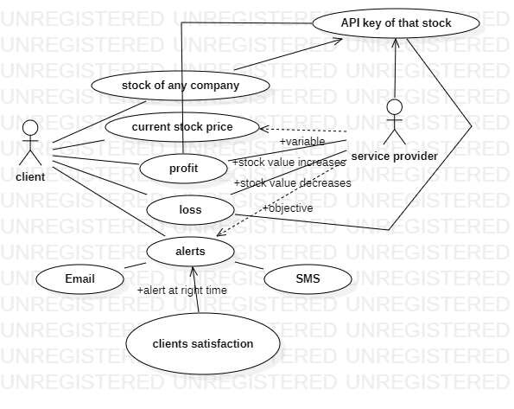

USECASE DIAGRAM FOR STOCK PRICE ALERT

Figure 2.4.1

**2.5 Sequence Diagram**

A sequence diagram is a type of interaction diagram because it describes how and in what order a group of objects works together. These diagrams are used by software developers and business professionals to understand requirements for a new system or to document an existing process.

Sequence diagrams are sometimes known as event diagrams or event scenarios. Sequence diagrams can be useful references for businesses and other organizations. Try drawing a sequence diagram to:

• Represent the details of a UML use case. • Model the logic of a sophisticated procedure, function, or operation.

• See how objects and components interact with each other to complete a process.

• Plan and understand the detailed functionality of an existing or future scenario.

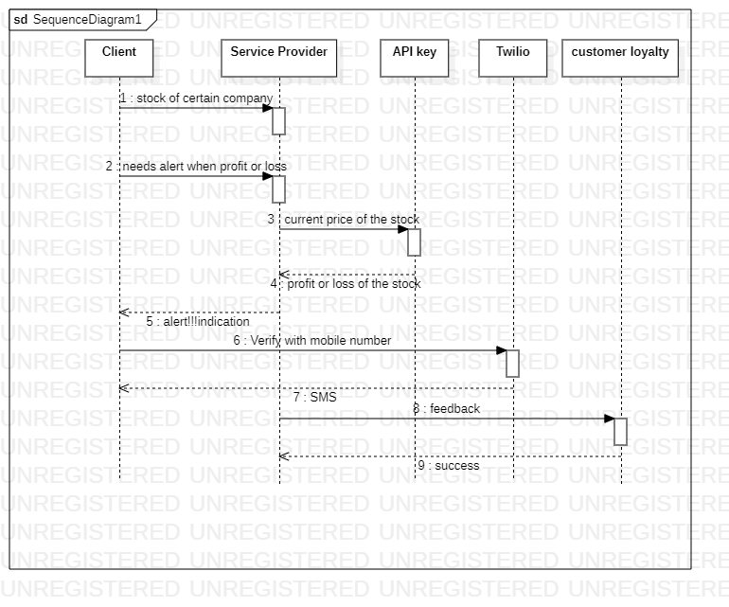

SEQUENCE DIAGRAM FOR STOCK PRICE ALERT

Figure 2.5.1

**3. IMPLEMENTATION**

**3.1. Implementation Details**

**3.1.1 Get API key from Alpha Vantage and Newsapi:**

Alpha Vantage and Newsapi provides free stock data. They were build to democratize the access to data for

the purpose of using in projects such as this.

**3.1.2 Import relevant packages:**

To get started with our project we need to make sure that we have all the relevant packages installed and

imported. It should import pandas ,time ,Timeseries ,Matplot,twilio for SMS services and smtplib library

files

**3.1.3 Pulling the data from Alpha Vantage and Newsapi:**

Using API key obtain from Alpha vantage, We can pull stock data for a particular time series for a particular

Stock like Microsoft as MSFT ,Apple’s stock as AAPl ,Facebook’s as FB Etc.,.

**3.1.4 Picking the right data:**

Alpha Vantage and Newspapi will by default output the following information for a stock.

For the purposes of this project, we will only use the close column which indicates the closing price of the

Stock for past five days

**3.1.5 Setting up the email notification:**

Now that we are able to pull the latest prices of the stock we desire. We can set up an email alert to notify us

when the time is right.Not only through mail,this project also notify the data/close price of the desired stock

for past five days

**3.2. Tools used**

**3.2.1 Hardware tools:**

* + - Minimum 2.8 GHz processor Computer System or latest version
    - 52X CD-ROM drive

**3.2.2 Software:**

* Python idle (3.10)
* Alpha vantage
* News API
* Twilio
* Libraries like pandas.matplot and smtplib etc,.

**4. TEST RESULTS/EXPERIMENTS/VERIFICATION** .

**4.1. Testing**

The Best Time of Day:

This is most applicable to intraday traders who buy and sell their stocks and make their profits within the trading hours on a single day. Logically, it may seem tedious to watch the market throughout the trading hours for an opportunity to buy or sell. However, this is not true for the following reasons:

>Too many hours watching charts and graphs causes mental fatigue and confusion.

>The volatility drops after the first 90 minutes.

>The volume in which stocks are traded might also drop after the first 90 minutes.

>You will face seasoned traders whose moves might leave you flustered. Experienced traders are looking to manipulate rates and turn graphs around - this is no time for a beginner to experiment.

The real case here is that to find the close stock price from stock market can’t be done in the weekdays. Because The Bombay Stock Exchange is open Monday through Friday from 9:15 am to 3:30 pm India Standard Time (GMT+05:30).

So the weekdays stock prices cant be stored in the panda or in the websites like alpha vantage and news api where the data of the stock can be get using the API

**4.2. Results**

Thus the alerts through sms and email was sent to the client when required, and is the main objective of our project is tested verified and executed successfully.

**4.3 Pseudocode**

ts = TimeSeries(key='K9VHHDQ753WTXHU4.', output_format='pandas')

data, meta_data = ts.get_intraday(symbol='MSFT',interval='1min', outputsize='full')

close_data = data['4. close']

last_price = close_data[0]

print(last_price)

yesterday = datetime.now() - timedelta(1)

yesterday = datetime.strftime(yesterday, '%Y-%m-%d')

previous_day = datetime.now() - timedelta(2)

previous_day = datetime.strftime(previous_day, '%Y-%m-%d')

two_days_before = datetime.now() - timedelta(3)

two_days_before= datetime.strftime(two_days_before, '%Y-%m-%d')

three_days_before = datetime.now() - timedelta(4)

three_days_before = datetime.strftime(three_days_before, '%Y-%m-%d')

# stock_value

response = requests.get(url=STOCK_ENDPOINT, params=stock_params)

response.raise_for_status()

stock_price = response.json()

yesterday_price = float(stock_price["Time Series (Daily)"][yesterday]["4. close"])

previous_day_price = float(stock_price["Time Series (Daily)"][previous_day]["4. close"])

two_days_before = float(stock_price["Time Series (Daily)"][two_days_before]["4. close"])

three_days_before = float(stock_price["Time Series (Daily)"][three_days_before]["4. close"])

KeyError:0

# percentage of difference between yesterday's and day before yesterday's

difference = yesterday_price - previous_day_price

if difference > 0:

fall_rise = "value decreased to"

else:

fall_rise = "value increased to"

abs_difference = abs(difference)

denominator = (yesterday_price + previous_day_price) / 2

percentage = round((abs_difference * 100) / denominator, 2)

Difference = two_days_before - three_days_before

if difference > 0:

fall_rise = "value decreased to"

else:

fall_rise = "value increased to"

abs_difference = abs(difference)

Denominator = (two_days_before + three_days_before) / 2

percentage = round((abs_difference * 100) / Denominator, 2)

if percentage > 5:

news_response = requests.get(url=NEWS_ENDPOINT, params=news_params)

news_response.raise_for_status()

top_news = news_response.json()

total_news = 3

list_of_news = []

for news_num in range(total_news):

list_of_news.append(top_news["articles"][news_num]["title"])

**4.4. Verification**

It was verified on different aspects such as all the given trained data is tested and correctly matched with the Users. Testing was done multiple times

Hence it is verified from the program and outputs are given below(Figure 4.1)

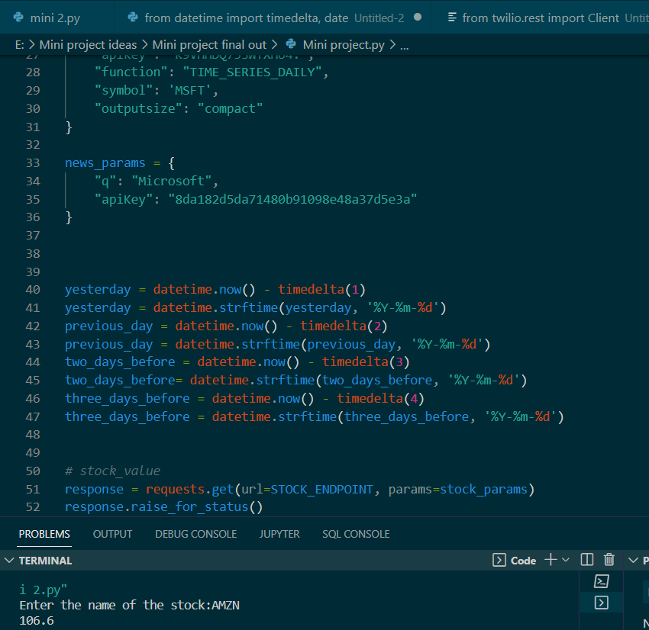

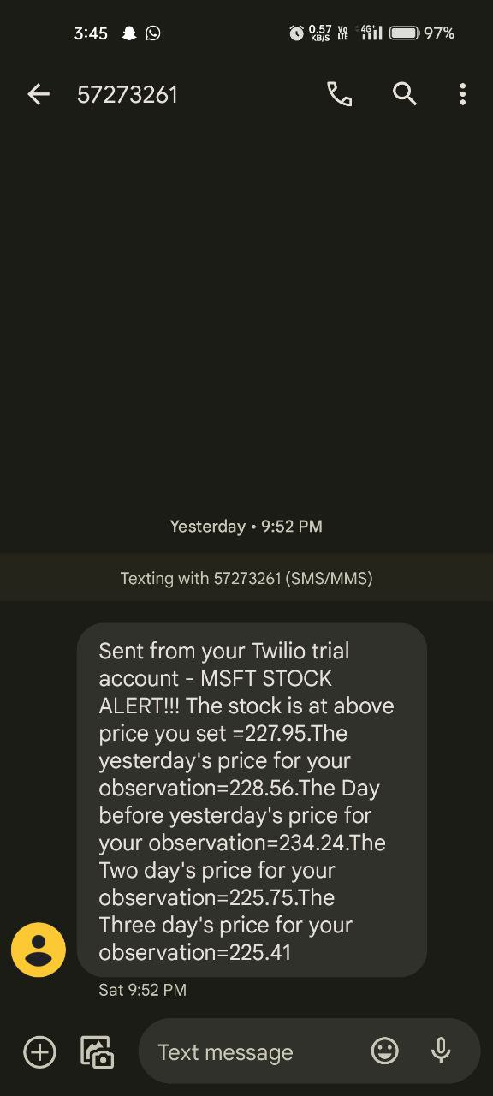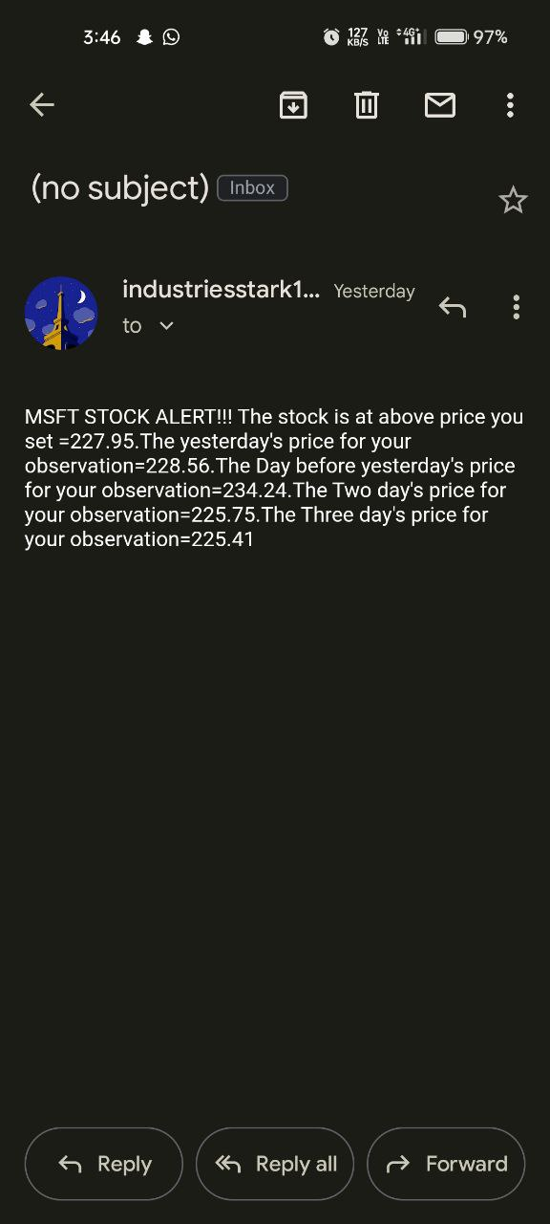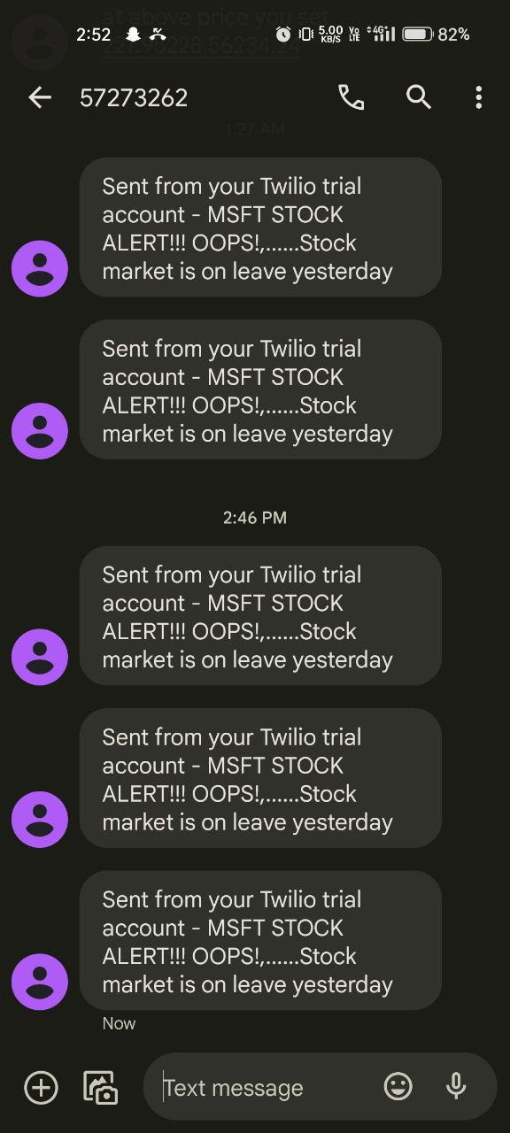

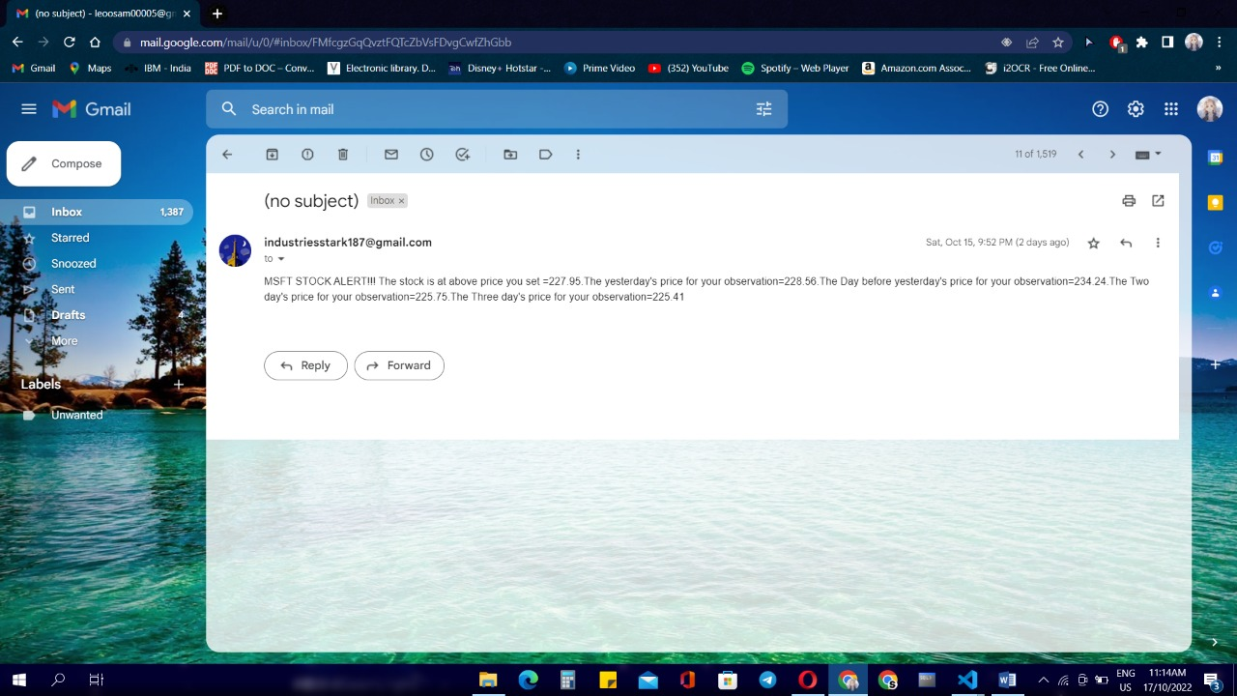

(Figure 4.1)

**5. CONCLUSION AND FURTHER SCOPE**

The above analysis can be used to understand a stock’s short-term and long-term behavior. A decision support system can be created which stock to pick from industry for low-risk low gain or high-risk high gain depending on the risk apatite of the investor.

There's no single "best" API for retrieving stock price data, but there are a few different options that you might consider depending on your needs. If you're just looking for basic price data for a few stocks, then the Yahoo! Finance API or the Google Finance API might be a good option.

If you need more comprehensive data, including historical prices, then you might want to consider something like the mboum API. Each of these APIs has its own advantages and disadvantages, so it's best to evaluate what your specific needs are before choosing one.

have also adopted. This package shall prove to be a powerful package in satisfying all the requirements of the school. The objective of software planning is to provide a frame work that enables the manger to make reasonable estimates made within a limited time frame at the beginning of the software project and should be updated regularly as the project progresses. In a nutshell, it can be summarized that the future scope of the project circles around maintaining information regarding: I. We can add printer in future. II.

We can give more advance software for Online Food Ordering System including more facilities III. We will host the platform on online servers to make it accessible worldwide IV. Integrate multiple load balancers to distribute the loads of the system V. Create the master and slave database structure to reduce the overload of the datab a sequeries VI. Implement the backup mechanism for taking backup of codebase and database on regular basis on different servers

**REFERENCE**

* <https://www.alphavantage.co/query>
* <https://newsapi.org/v2/everything>
* <https://www.twilio.com/try-twilio>
* <https://www.wikipedia.org>
* Google for problem solving
* <https://www.youtube.com>
* <https://blog.finxter.com>
* <https://stackoverflow.com>
* <https://www.geeksforgeeks.org>

[1]F. a. o. Eugene, "Efficient capital markets: a review of theory and empirical work," Journal of

finance, vol. 25, no. 2, pp. 383-417, 1970.

[2]Z. A. Farhath, B. Arputhamary and L. Arockiam, "A Survey on ARIMA Forecasting Using Time

Series Model," Int. J. Comput. Sci. Mobile Comput, vol. 5, pp. 104-109, 2016.

[3]S. Wichaidit and S. Kittitornkun, "Predicting SET50 stock prices using CARIMA (cross correlation

ARIMA)," in 2015 International Computer Science and Engineering Conference (ICSEC), IEEE,

2015, pp. 1-4.

[4]D. Mondal, G. Maji, T. Goto, N. C. Debnath and S. Sen, "A Data Warehouse Based Modelling

Technique for Stock Market Analysis," International Journal of Engineering & Technology, vol. 3,

no. 13, pp. 165-170, 2018.

[5]G. Maji, S. Sen and A. Sarkar, "Share Market Sectoral Indices Movement Forecast with Lagged

Correlation and Association Rule Mining," in International Conference on Computer Information

[6] M. Roondiwala, H. Patel and S. Varma, "Predicting stock prices using LSTM," International

Journal of Science and Research (IJSR), vol. 6, no. 4, pp. 1754-1756, 2017.

[7] T. Kim and H. Y. Kim, "Forecasting stock prices with a feature fusion LSTM-CNN model using

different representations of the same data," PloS one, vol. 14, no. 2, p. e0212320, April 2019.

[8] S. Selvin, R. Vinayakumar, E. A. Gopalkrishnan, V. K. Menon and K. P. Soman, "Stock price

prediction using LSTM, RNN and CNN-sliding window model," in International Conference on

Advances in Computing, Communications and Informatics, 2017.

[9] S. Hochreiter, "Untersuchungen zu dynamischen neuronalen Netzen," Diploma, Technische

Universität München, vol. 91, no. 1, 1991.

[10] Y. Bengio, P. Simard, P. Frasconi and others, "Learning long-term dependencies with gradient

descent is difficult," IEEE transactions on neural networks, vol. 5, no. 2, pp. 157-166, 1994.

[11] S. Hochreiter and J. Schmidhuber, "LSTM can solve hard long time lag problems," in Advancesin

neural information processing systems, NIPS, 1997, pp. 473--479.

[12] S. Hochreiter, "The vanishing gradient problem during learning recurrent neural nets and problem

solutions," International Journal of Uncertainty, Fuzziness and Knowledge-Based Systems, vol. 6,

no. 2, pp. 107-116, 1998.

[13] J. Schmidhuber, D. Wierstra, M. Gagliolo and F. Gomez, "Training recurrent networks by

evolino," Neural computation, vol. 19, no. 3, pp. 757-779, 2007.

[14] L. Pasa and A. Sperduti, "Pre-training of recurrent neural networks via linear autoencoders," in

Advances in Neural Information Processing Systems, NIPS, 2014, pp. 3572-3580.

[15] J. Chen and N. S. Chaudhari, "Segmented-memory recurrent neural networks," IEEE transactionson

neural networks, vol. 20, no. 8, pp. 1267-1280, 2009.

[16] S. Hochreiter and J. Schmidhuber, "Long short-term memory," Neural computation, vol. 9, no. 8,pp.

1735-1780, 1997.

[17] R. S. Sutton and A. G. Barto, Reinforcement learning: An introduction, MIT Press, 2018.

[18] F. A. Gers and J. Schmidhuber, "Recurrent nets that time and count," in Proceedings of the IEEEINNS-ENNS International Joint Conference on Neural Networks. IJCNN 2000. Neural Computing:

New Challenges and Perspectives for the New Millennium, IEEE, 2000, pp. 189- 194.